Computer Science
Program File

Question 1- WAP using overloaded function to compute the area of rectangle and area of triangle using heron’s formula.

Code
#include<iostream.h>
#include<conio.h>
#include<stdlib.h>
class distance{int feet,inch;
public: void getdata()
{int f,i;
cout<<"\nEnter the value(feet):: ";
cin>>f;
cout<<"\nInches:: ";
cin>>i;
feet=f;inch=i;
}
void dispdata()
{cout<<"feet= "<<feet<<" Inches : "<<inch; }
distance sum(distance d)
{distance d1;
d1.feet=feet+d.feet+(inches+d.inches)/12;
d1.inches=(inches+d.inches)%12;
}
};
void main()
{ clrscr();
distance l1,l2,total;
l1.getdata();
l2.getdata();
total=l1.sum(l2);
total.dispdata();
getch();}

Output
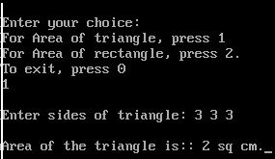

Question 2- Define a class TRAVEL with the following descriptions :
Private members are :
Tcode, no_of_pass, no_of_buses integer (ranging from 0 to 55000)
Place string
Public members are:
- A constructor to assign initial values of Tcode as 101, Place as “Varanasi”, no_of_pass as 5, no_of_buses as 1.
- A function INDETAILS( ) to input all information except no_of_buses according to the following rules :
Number of passengers Number of buses
Less than 40 1
Equal to or more than 40 & less than 80 2
Equal to or more than 80 3
A function OUTDETAILS( ) to display all the information
WAP to implement that reads the No of Passengers & depending upon displays all the details including no of
buses required.
CODE
#include<iostream.h>
#include<conio.h>
#include<string.h>
#include<stdio.h>
class travel{long int tcode,nofbus,nofpass;
char place[20];
public:
travel()
{ tcode=101;
strcpy(place,"Varanasi");
nofpass=5;
nofbus=1;
}
void INDETAILS()
{cout<<"\nEnter Travel Code:: ";
cin>>tcode;
cout<<"\nEnter the place:: ";
gets(place);
cout<<"\nEnter the No. of Passengers:: ";
cin>>nofpass;
cal();
}
void cal()
{if (nofpass<40) nofbus=1;
else if (nofpass<80) nofbus=2;
else nofbus=3;
}
void OUTDETAILS()
{cout<<"\n\nThe Details Are as follows-";
cout<<"\nTravel Code:: "<<tcode;
cout<<"\nPlace:: "<<place;
cout<<"\nNo.of Passengers:: "<<nofpass;
cout<<"\nNo. of Buses:: "<<nofbus;
}

};

void main()
{ clrscr();
travel t;
t.INDETAILS();
t.OUTDETAILS();
getch();
}

OUTPUT
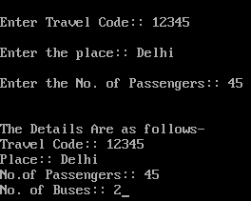

Question 3- Define a class Resort in C ++ with the following description :

Private members :
Rno // Data member to store room no
Name // Data member to store customer name
Charges // Data member to store per day charges
Days // Data member to store number of days of stay
Compute( ) // A function to calculate and return amount as days*charges and
if the value of days*charges is more than 11000 then as
1.02 *days*charges.
Public Members :
Getinfo( ) // A function to enter the content Rno, Name, charges and days.
Dispinfo( ) // A function to display Rno,Name,Charges, Days and Amount
(Amount to be displayed by calling function Compute( ))

WAP that implements the above class.
CODE
#include<iostream.h>
#include<conio.h>
#include<math.h>
#include<stdio.h>
class resort{int rno,d;
char name[20];
float ch;
float compute()
{ float a=ch*d;
if(a>11000)
a=1.02*d*ch;
return a;
}
public:
void getinfo();
void dispinfo();
};
void resort::getinfo()
{cout<<"\nEnter Room no. :: ";
cin>>rno;
cout<<"\nEnter your name:: ";
gets(name);
cout<<"\nEnter charges and days:: ";
cin>>ch>>d;
}
void resort::dispinfo()
{cout<<"\nRoom no:: "<< rno;
cout<<"\nName:: "<<name;
cout<<"\nCharges and days:: "<<ch<< " " <<d;
cout<< "\nAmount ::"<<compute();
}
void main()
{ clrscr();
resort r1;
cout<<"\nEnter the details:: ";
r1.getinfo();
cout<<"\nThe entered details are:: ";
r1.dispinfo();
getch();
}

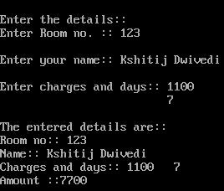

Question 4- Write a program to add two instances of distance class (having data members feet and inches). Make suitable assumptions.
CODE
#include<iostream.h>
#include<conio.h>
#include<math.h>
#include<stdio.h>
class resort{int rno,d;
char name[20];
float ch;
float compute()
{ float a=ch*d;
if(a>11000)
a=1.02*d*ch;
return a;
}
public:
void getinfo();
void dispinfo();
};
void resort::getinfo()
{cout<<"\nEnter Room no. :: ";
cin>>rno;
cout<<"\nEnter your name:: ";
gets(name);
cout<<"\nEnter charges and days:: ";
cin>>ch>>d;
}
void resort::dispinfo()
{cout<<"\nRoom no:: "<< rno;
cout<<"\nName:: "<<name;
cout<<"\nCharges and days:: "<<ch<< " " <<d;
cout<< "\nAmount "<<compute();
}
void main()
{ clrscr();
getinfo();
dispinfo();
getch();
}
OUTPUT
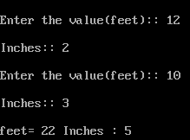

Question 5- Write a C++ program using classes and objects to simulate result preparation system for 10 students. The data available for each student includes rollno, name, marls,in 3 subjects. The percentage marks and grade are to be calculated from the given information. The percentage marks are the average marks and the grade ias calculated as follows:
Percentage Marks Grade
<50 F
>=50 & <60 D
>=60 & <75 C
>=75 & <90 B
>=90 & <=100 A
CODE
#include<iostream.h>
#include<conio.h>
#include<math.h>
#include<stdio.h>
class stud{int rno;
int m[3];
char name[20];
char grade;
float avg;
public:
void getdata();
void cal();
void dispdata();
};
void stud::getdata()
{cout<<"\nEnter your roll no. :: ";
cin>>rno;
cout<<"\nEnter your name:: ";
gets(name);
for(int i=0;i<3;i++)
{cout<<"\nEnter marks in "<<i+1<<" subject:: ";
cin>>m[i];}
cout<<"\n";
}
void stud::cal()
{avg=(m[0]+m[1]+m[2])/3;
if(avg<50) grade='F';
else if(avg<60) grade='E';
else if(avg<70) grade='D';
else if(avg<80) grade='C';
else if(avg<90) grade='B';
else grade='A';
}
void stud::dispdata()
{cout<<"\nName:: "<<name;
cout<<"\nRoll No.:: "<<rno;
cout<<"\nPercentage marks:: "<<avg;
cout<<"\nGrade:: "<<grade;
}
void main()
{ clrscr();
int n=0;
cout<<"\nEnter the no. of Students(less than 10):: ";
cin>>n;
stud XII[10];
for(int i=0;i<n;i++)
{ cout<<"\nSudent "<<i+1<<":: ";
XII[i].getdata();
}
for(i=0;i<n;i++)
{
XII[i].cal();
cout<<"\nResults of Student"<<i+1<<":: ";
XII[i].dispdata();
}
getch();
}
OUTPUT
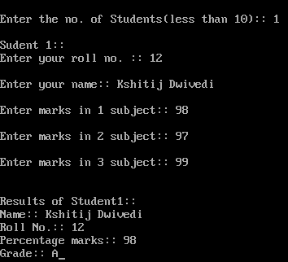

6.Write a program using functions in C++ to read the content from a text file STORY.TXT, count and display the number of alphabets present in it.
CODE
#include<fstream.h>
#include<ctype.h>
void main()
{fstream f("STORY.TXT",ios::in);
char ch;
int count=0;
while(f)
{f.get(ch);
if(isalpha(ch))
count++;
}
f.close();
}

7.Write a function in C++ to read the content from a text file NOTES. TXT, count and display the number of blank spaces present in it.
CODE
#include<fstream.h>
#include<ctype.h>
void main()
{fstream f("NOTES.TXT",ios::in);
char ch;
int count=0;
while(f)
{f.get(ch);
if(ch==' ')
count++;
}
f.close();
}

8.Assuming the class EMPLOYEE given below, write a program using functions in C++ to perform the following:-
- Write the objects of EMPLOYEE to binary file.
- Reads the objects of EMPLOYEE from binary file and display them on screen.
Class EMPLOYEE
{
int ENC;
char ENAME[0];
PUBLIC:
Void GETIT(){ cin>> ENO;gets(ENAME);}
Void SHOWIT() { cout>> ENO<<ENAME;<<endl; }
};

CODE
#include<fstream.h>
#include<stdio.h>
#include<conio.h>
class employee
{
int ENO;
char ENAME[15];
public:
void getit()
{ cout<<"\nEnter employee No. :: ";
cin>> ENO;
cout<<"\nEnter Emplyee Name :: ";
gets(ENAME);
}
void showit()
{ cout<<"\nEmployee No. :: "<<ENO;
cout<<"\nEmployee Name:: "<<ENAME;
}
};

void main()
{clrscr();
employee e,g;
char ch;
fstream f("employee.dat",ios::out|ios::binary);
do
{
e.getit();
f.write((char*)&e,sizeof(e));
cout<<"\nWant to enter more Records(Y/N):: ";
cin>>ch;
}
while(ch=='y'||ch=='Y');
f.close();
f.open("employee.dat",ios::in|ios::binary);
while(!f.eof())
{f.read((char*)&e,sizeof(e));
e.showit();
}
f.close();
getch();
}
OUTPUT
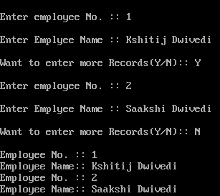

9). Assuming that a text file named TEXT1.TEXT already contains some text written into it, write a function named vowelwords(), that reads the file TEXT1.TEXT and creates a new file named TEXT2.TEXT,which shall contain only those words from the file TEXT1.TEXT which does not start
with an uppercase vowel(i.e, with ‘A’,’E’,’I’,’O’,’U’). FOR example, if the file TEXT1.TXT
CODE
#include<fstream.h>
#include<stdio.h>
#include<conio.h>
#include<string.h>
void main()
{clrscr();
char w[15],str[80];
fstream fin("TEXT1.txt",ios::out);
cout<<"\nEnter Contents in the file(max. 80 characters):: ";
while(strlen (gets(str))>0)
{fin<<str;
fin<<"\n";
}
fin.close();
fin.open("TEXT1.txt",ios::in);
ofstream fout("TEXT2.txt",ios::out);
cout<<"\nThe words starting with vowels are as follows:: ";
while(fin)
{fin>>w;
if(w[0]=='a'||w[0]=='e'||w[0]=='i'||w[0]=='o'||w[0]=='u'||w[0]=='A'||w[0]=='E'||w[0]=='I'||w[0]=='O'||w[0]=='U')
{cout<<w<<" ";
fout<<w<<" ";
}
}
cout<<"\nThese words are written in the file. ";
fin.close();
getch();
}
OUTPUT
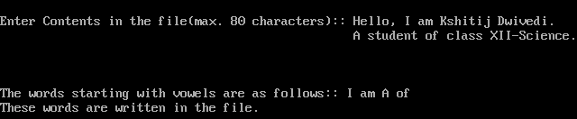

10.Write a C++ program, which initializes a string variable to the content. “ Anil is a great teacher but unfortunately it kills all its pupils. Harimohan” and output the srtring one character at a time to the disk file OUT.TXT. You have to include all the header files if required.
CODE
#include<fstream.h>
#include<stdio.h>
#include<conio.h>
#include<string.h>
void main()
{clrscr();
char w,str[80];
fstream fin("TEXT1.txt",ios::out);
cout<<"\nEnter Contents in the file(max. 80 characters):: ";
while(strlen (gets(str))>0)
{fin<<str;
fin<<"\n";
}
fin.close();
fin.open("TEXT1.txt",ios::in);
cout<<"\nYour content character by character is as follows:: ";
while(fin)
{fin.get(w);
cout<<w<<" ";
}
fin.close();
getch();
}
OUTPUT
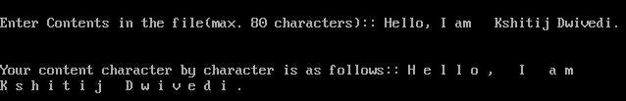

11.Write a C++ program, which reads one line at a time form the disk file TEST.TXT, and displays it to a monitor. Your program has to read all the contents of the file. Assume the length of the line not to exceed 80 characters. You have to include all the header files if required.
CODE
#include<fstream.h>
#include<stdio.h>
#include<conio.h>
#include<string.h>
void main()
{clrscr();
char ch[80];
ifstream fin("TEXT2.txt",ios::in);
cout<<"\nThe lines of the file are:: "<<"\n\n";
while (!fin.eof())
{ fin.getline(ch,80);
cout<<ch;
cout<<"\n";
}
fin.close();
getch();
}

OUTPUT
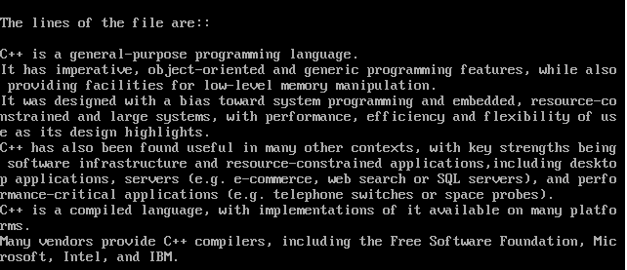

12.A text file named “report.txt” exists on a disk. Write a program to create its copy named “Finerep.txt”, which should be in small letters but the first letter of the file and first alphabetic character following a full stop should be in uppercase.
CODE
#include<fstream.h>
#include<stdio.h>
#include<conio.h>
#include<string.h>
#include<ctype.h>
void main()
{clrscr();
char s[80];
fstream fin("qwerty.txt",ios::in);
fstream fout("qwertyuiop.txt",ios::out);
cout<<"\nContent of the new file is:: ";
cout<<"\n";
while(fin)
{fin.getline(s,80,'\n');
for(int i=0;s[i]!='\0';i++)
{s[0]=toupper(s[0]);
if (s[i]=='.')
{s[i+1]=toupper(s[i+1]);
cout<<s;
}
}
fin.close();
fout.close();
getch();
}
}
OUTPUT
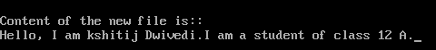

POINTERS
Q 1) Write a program using function substr() that will scan a string for the occurrence of a given string for the occurrence of a given sub-string. The prototype of the function would be:
char * substr(char * string1, char *string2);
The function should return a pointer to the element in string1 where string2 begins. If string2 doesn’t occur in string1 then substr should return a NULL.

CODE
#include<iostream.h>
#include<conio.h>
#include<stdio.h>
char *get_substr(char *sub,char *str)
{
char *p,*p2,*start;
for(int i=0;str[i]!='\0';i++)
{ p=&str[i];
start=p;
p2=sub;
while (*p2!='\0'&&*p2==*p)
{p++;
p2++;}
if(!*p2)
return start;
}
return 0;
}
void main()
{clrscr();
char *substr,*str;
cout<<"\nEnter the string:: ";
gets(str);
cout<<"\nEnter the Substring:: ";
gets (substr);
substr=get_substr(substr,str);
if (substr!='\0')
cout<<"\nSubstring Found in:: "<<substr;
else
cout<<"\nSubtring Not Found. ";
getch();
}
OUTPUT
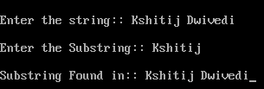

2) WAP to reverse a string using pointer
CODE
#include<iostream.h>
#include<conio.h>
#include<stdio.h>
#include<string.h>
#include<process.h>
void reverse(char *str)
{int l,c;
char *beg,*end,temp;
l=strlen(str);
beg=end=str;
for(c=0;c<(l-1);c++)
end++;
for(c=0;c<l/2;c++)
{temp=*end;
*end=*beg;
*beg=temp;
beg++; end--;
}
}
void main()
{clrscr();
char str[80];
cout<<"\nEnter a string:: ";
gets(str);
reverse(str);
cout<<"\nReverse of the string is:: "<<str;
getch();
}
OUTPUT
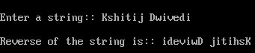

WAP to input a string & find its length using pointer.
CODE
#include<conio.h>
#include<stdio.h>
#include<string.h>
#include<process.h>
#include<iostream.h>
int str_length(char *str)
{int i=0;
while(*(str+i)!='\0')
i++;
return i;
}
void main()
{clrscr();
char str[40];
cout<<"\nEnter a string:: ";
gets(str);
int l=str_length(str);
cout<<"\nLength of the string is :: "<<l;
getch();
}
OUTPUT
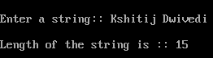

WAP using function replace having prototype Int replace(char *s, char c1, char c2); which replaces every occurrence of c1 in the string s with c2, and returns the number of replacements it made.

CODE
#include<conio.h>
#include<stdio.h>
#include<string.h>
#include<process.h>
#include<iostream.h>
int replace(char *str,char ch1, char ch2)
{int c=0;
char *nstr=new char[strlen(str)+1];
int n=0;
while(*str!='\0')
{if (*str==ch1)
{nstr[n]=ch2;
c++;
}
else
nstr[n]=*str;
str++;
n++;}
nstr[n]='\0';
cout<<nstr;
return c;
}
void main()
{clrscr();
char *str="Welcome To C++";
char ch='+';
char c='K';

int changes=replace(str,ch,c);
cout<<"\nChanged String:: "<<str;
cout<<"\nNo. of Changes made are:: "<<changes;

getch();
}
OUTPUT
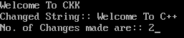

WAP using functions to compress any given string such that the multiple blanks present in it are eliminated.The function should return the compressed string.

CODE
#include<conio.h>
#include<stdio.h>
#include<string.h>
#include<process.h>
#include<iostream.h>
void removespace(char *s)
{char *beg=s;
char *end=s;
while(*beg)
{if (*beg==' ')
*beg++;
else
*end++=*beg++;
}
*end=0;
}
void main()
{clrscr();
char str[20];
cout<<"\nEnter any string:: ";
gets(str);
cout<<"\nChanged string is:: ";
removespace(str);
puts(str);
getch();
}

OUTPUT
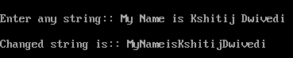

WAP using fuction that takes two string arguments and returns the concatenated string.

CODE
#include<conio.h>
#include<stdio.h>
#include<string.h>
#include<process.h>
#include<iostream.h>
void stringcat(char *str1,char *str2)
{int i = 0,len = 0;
while(*(str1+len)!='\0')
len++;
while(*(str2+i)!='\0')
{
*(str1+len) = *(str2+i);
i++;
len++;
}
*(str1+len) = '\0';
}
void main()
{clrscr();
char *str1,*str2;
cout<<"\nEnter First String:: ";
gets(str1);
cout<<"\nEnter Second String :: ";
gets(str2);
stringcat(str1,str2);
cout<<"\nThe CONCATENATED Strings are:: ";
puts(str1);
getch();
}
OUTPUT
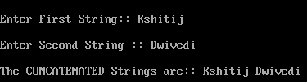

ARRAYS

Q 1) WAP using functions in C++, which accepts an integer array and its size as parameters and rearranges the array in reverse.
Example:If an array of nine elements initially contains the elements as 4, 2, 5, 1, 6, 7, 8, 12, 10
Then the function should rearrange the array as 10,12, 8, 7, 6, 1, 5, 2, 4
CODE
#include<conio.h>
#include<stdio.h>
#include<string.h>
#include<process.h>
#include<iostream.h>

void main()
{clrscr();
int a[50],i,n,j,temp;
cout<<"\nEnter any size:: ";
cin>>n;
cout<<"\nEnter array elements:: ";
for(i=1;i<=n;i++)
cin>>a[i];
cout<<"\nThe array you entered is:: ";
for(i=1;i<=n;i++)
cout<<a[i]<<"\t";
for(i=1;i<=n;i++)
{for(j=1;j<=n;j++)
{temp=a[i];
a[i]=a[j];
a[j]=temp;
}
}
cout<<"\nThe rearranged array is:: ";
for(i=1;i<=n;i++)
cout<<a[i]<<"\t";
getch();
}

OUTPUT
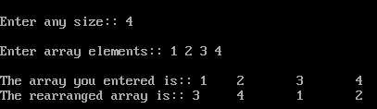

2) Write a program using function in C++, which accepts an integer array and its size as arguments and swap the elements of every even location with its following odd location.
Example : If an array of nine elements initially contains the elements as 2,4,1,6,5,7,9,23,10
then the function should rearrange the array as 4,2,6,1,7,5,23,9,10

CODE
#include<conio.h>
#include<stdio.h>
#include<string.h>
#include<process.h>
#include<iostream.h>
void main()
{clrscr();
int a[50],i,n,j,temp;
cout<<"\nEnter any size:: ";
cin>>n;
cout<<"\nEnter array elements:: ";
for(i=0;i<n;i++)
cin>>a[i];
cout<<"\nThe array you entered is:: ";
for(i=0;i<n;i++)
cout<<a[i]<<"\t";
for(i=0;i<(n-1);i+=2)
{temp=a[i];
a[i]=a[i+1];
a[i+1]=temp;
}
cout<<"\nThe rearranged array is:: ";
for(i=0;i<=n;i++)
cout<<a[i]<<"\t";
getch();
}
OUTPUT
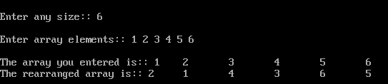

3.) WAP using function in C++ which accepts an integer array and size as arguments and replaces elements having odd values with thrice its value and elements having even values with twice its value.
Example : if an array of five elements initially contains elements as 3, 4, 5, 16, 9
The the function should rearrange the content of the array as 9, 8, 75, 32, 27

CODE
#include<conio.h>
#include<stdio.h>
#include<string.h>
#include<process.h>
#include<iostream.h>
void main()
{clrscr();
int a[50],i,n,j,temp;
cout<<"\nEnter any size:: ";
cin>>n;
cout<<"\nEnter array elements:: ";
for(i=0;i<n;i++)
cin>>a[i];
cout<<"\nThe array you entered is:: ";
for(i=0;i<n;i++)
cout<<a[i]<<"\t";
for(i=0;i<n;i++)
{if (a[i]%2==0)
a[i]*=2;
else a[i]*=3;
}
cout<<"\nThe rearranged array is:: ";
for(i=0;i<n;i++)
cout<<a[i]<<"\t";
getch();
}
OUTPUT
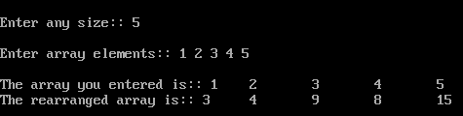

4) Write a function in C++ which accepts a 2D array of integers and its size as arguments and displays the elements of middle row and the elements of middle column. [Assuming the 2D Array to be a square matrix with odd dimension i.e., 3x3, 5x5, 7x7 etc…]
Example : If the array content is
3 5 4
7 6 9
2 1 8
Output through the function should be :
Middle Row : 7 6 9
Middle Column : 5 6 1

CODE
#include<conio.h>
#include<stdio.h>
#include<string.h>
#include<process.h>
#include<iostream.h>
void disp_diagonal(int matrix[10][10],int r,int c)
{cout<<"\nDiagonal One:: ";
for (int i=0;i<r;i++)
for (int j=0;j<c;j++)
if(i==j)
cout<<matrix[i][j]<<" ";
cout<<"\nDiagonal Two:: ";
for(i=0;i<r;i++)
for(j=c-1;j>=0;j--)
{cout<<matrix[i][j]<<" "; i++;}
}
void main()
{clrscr();
int matrix[10][10],i,j,r,c;
cout<<"\nEnter no. of rows:: ";
cin>>r;
cout<<"\nEnter no. of columns:: ";
cin>>c;
cout<<"\nInput values::";
for(i=0;i<r;i++)
for(j=0;j<c;j++)
cin>>matrix[i][j];
disp_diagonal(matrix,r,c);
getch();
}
OUTPUT
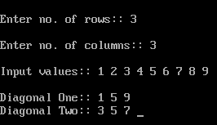

5) Write function in C++ which accepts an integer array and size as arguments and assign values into a 2D array of integers in the following format :
If the array is 1, 2, 3, 4, 5, 6
The resultant 2D array is given below
1 2 3 4 5 6
1 2 3 4 5 0
1 2 3 4 0 0
1 2 3 0 0 0
1 2 0 0 0 0
1 0 0 0 0 0
If the array is 1, 2, 3
The resultant 2D array is given :
- 2 3
- 2 0
1 0 0

CODE
#include<conio.h>
#include<stdio.h>
#include<string.h>
#include<process.h>
#include<iostream.h>
void disp_conver(int arr[],int size)
{int matrix[10][10];
for(int i=0;i<size;i++)
{for(int j=0;j<size;j++)
if((i+j)>=size)
matrix[i][j]=0;
else
matrix[i][j]=arr[j];
}
cout<<"\nYour resultant 2-D array is:: ";
for(i=0;i<size;i++)
{cout<<"\n";
for(int j=0;j<size;j++)
cout<<matrix[i][j]<<"\t";
}
}
void main()
{clrscr();
int arr[10],i,size;
cout<<"\nEnter the size(no. of rows or columns):: ";
cin>>size;
cout<<"\nInput values:: ";
for(i=0;i<size;i++)
cin>>arr[i];
disp_conver(arr,size);
getch();
}
OUTPUT
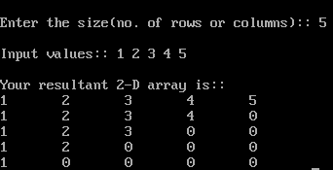

6)Write a function in C++ which accepts an integer array and its size as arguments and exchanges the values of first half side elements with the second half side elements of the array.
Example :
If an array of 8 elements initial content as 2, 4, 1, 6, 7, 9, 23, 10
The function should rearrange array as 7, 9, 23, 10, 2, 4, 1, 6

CODE
#include<conio.h>
#include<stdio.h>
#include<string.h>
#include<process.h>
#include<iostream.h>
void main()
{clrscr();
int a[50],i,n,j,temp;
cout<<"\nEnter any size:: ";
cin>>n;
cout<<"\nEnter array elements:: ";
for(i=0;i<n;i++)
cin>>a[i];
cout<<"\nThe array you entered is:: ";
for(i=0;i<n;i++)
cout<<a[i]<<"\t";
for(i=0,j=n/2;j<n;i++,j++)
{temp=a[i];
a[i]=a[j];
a[j]=temp;
}
cout<<"\nThe rearranged array is:: ";
for(i=0;i<n;i++)
cout<<a[i]<<"\t";
getch();
}

OUTPUT
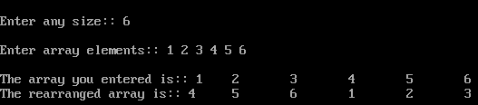

7) Given two arrays of integers X and Y of sizes m and n respectively. Write a function named MERGE() which will third array named Z, such that the following sequence is followed.
- All odd numbers of X from left to right are copied into Z from left to right.
- All even numbers of X from left to right are copied into Z from right to left.
- All odd numbers of Y from left to right are copied into Z from left to right.
- All even numbers of Y from left to right are copied into Z from right to left.
X, Y and Z are passed as arguments to MERGE().
Eg. X is {3, 2, 1, 7, 6, 3} and {9, 3, 5, 6, 2, 8, 10}
the resultant array Z is {3, 1, 7, 3, 9, 3, 5, 10, 8, 2, 6, 6, 2}

CODE
#include<conio.h>
#include<stdio.h>
#include<string.h>
#include<process.h>
#include<iostream.h>
void arrays(int x[],int y[], int z[], int m, int n)
{int mn,l=0;
mn=m+n;
int r=mn-1;
for(int i=0;i<m;i++)
if (x[i]%2==1)
z[l++]=x[i];
else
z[r--]=x[i];
for (i=0;i<n;i++)
if (y[i]%2==1)
z[l++]=y[i];
else
z[r--]=y[i];
cout<<"\nThe reultant array is:: \n";
for (i=0;i<mn;i++)
cout<<z[i]<<"\t";
}
void main()
{clrscr();
int x[10],y[10],z[10]={0};
int m,n;
cout<<"\nEnter the size of 1st array:: ";
cin>>m;
cout<<"\nEnter the size of 2nd array:: ";
cin>>n;
cout<<"\nInput values(Array 1)::";
for(int i=0;i<m;i++)
cin>>x[i];
cout<<"\nInput Values(Array 2)::";
for(i=0;i<n;i++)
cin>>y[i];
arrays(x,y,z,m,n);
getch();
}

OUTPUT
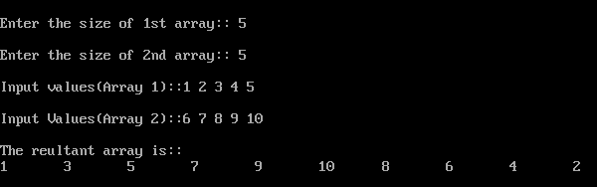

8) Write a function in C++ which accepts a 2D array of integers and its size as arguments
and displays elements which are exactly two digit number.
If 2D array is
Output is
14 25 32 45 11 28 18

CODE
#include<conio.h>
#include<stdio.h>
#include<string.h>
#include<process.h>
#include<iostream.h>
void twodigit(int arr[][10],int r,int c)
{
cout<<"\nThe two digit numbers are:: ";
for(int i=0;i<r;i++)
for(int j=0;j<c;j++)
{if(arr[i][j]>9&&arr[i][j]<100)
cout<<arr[i][j]<<"\t";
}
}
void main()
{clrscr();
int arr[10][10],i,j,r,c;
cout<<"\nEnter the no. of rows:: ";
cin>>r;
cout<<"\nEnter the no. of columns:: ";
cin>>c;
cout<<"\nInput values:: ";
for(i=0;i<r;i++)
for(j=0;j<c;j++)
cin>>arr[i][j];
cout<<"\nYour matrix is:: ";
for(i=0;i<r;i++)
{cout<<"\n";
for(int j=0;j<c;j++)
cout<<arr[i][j]<<"\t";
}
twodigit(arr,r,c);
getch();
}
OUTPUT
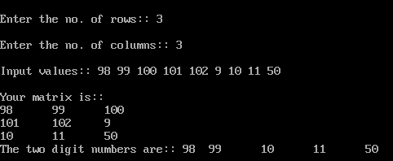

MYSQL
Q. Write SQL Queries to create the tables & insert the specified rows for the following ::

Table : SchoolBus
Rtno | Area_overed | Capacity | Noofstudents | Distance | Transporter | Charges
1 | Vasant kunj | 100 | 120 | 10 | Shivamtravels | 100000
2 | Hauz Khas | 80 | 80 | 10 | Anand travels | 85000
3 | Pitampura | 60 | 55 | 30 | Anand travels | 60000
4 | Rohini | 100 | 90 | 35 | Anand travels | 100000
5 | Yamuna Vihar | 50 | 60 | 20 | Bhalla Co. | 55000
6 | Krishna Nagar | 70 | 80 | 30 | Yadav Co. | 80000
7 | Vasundhara | 100 | 110 | 20 | Yadav Co. | 100000
8 | Paschim Vihar | 40 | 40 | 20 | Speed travels | 55000
9 | Saket | 120 | 120 | 10 | Speed travels | 100000
10 | Jank Puri | 100 | 100 | 20 | Kisan Tours | 95000
a)To show all information of students where capacity is more than the no of student in order of rtno.
- To show area_covered for buses covering more than 20 km., but charges less then 80000.
- To show transporter wise total no. of students traveling.
- To show rtno, area_covered and average cost per student for all routes where average cost per student is - charges/noofstudents.
- Add a new record with following data:
(11, “ Moti bagh”,35,32,10,” kisan tours “, 35000)

Create table Schoolbus(Rno int,Area_Covered char(30), Capacity int, No_of_Students int, Distance int,Transporter char(30),Charges int);
Insert into Graduate values(1,’Vasant Kunj’,100,120,10,’Shivam Travels’,10000,);
Insert into Graduate values(2,’Hauz Khas’,80,80,10,’Anand Travels’,85000,);
Insert into Graduate values(3,’Pitampura’,60,55,30,’Anand Travels’,60000,);
Insert into Graduate values(4,’Rohini’,100,90,35,’Anand Travels’,100000,);
Insert into Graduate values(5,’Yamuna Nagar’,50,60,20,’Bhalla Co’,55000,);
Insert into Graduate values(6,’Krishana Nagar’,70,80,30,’Yadav Co’,80000,);
Insert into Graduate values(7,’Vasundhara’,100,110,20,’Yadav Co’,100000,);
Insert into Graduate values(8,’Paschim vihar’,40,40,10,’Speed Travels’,55000,);
Insert into Graduate values(9,’Saket’,120,120,10,’Speed Travels’,100000,);
Insert into Graduate values(10,’Jank Puri’,100,100,20,’Kisan Tours’,95000,);

- Select * from Schoolbus where capacity>No_of_Students order by rno;

- Select Area_Covered from schoolbus where distance>20 and charges<80000;
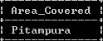

- Select Treansporter, No_of_Students from schoolbus order by transporter;
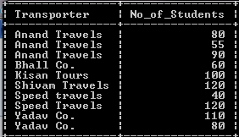

- Select rno,Area_covered from schoolbus;
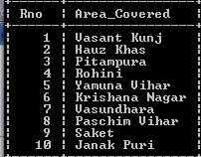
- Insert into Graduate values(11,’Moti bagh’,35,32,10,’Kisan Tours’,35000,);
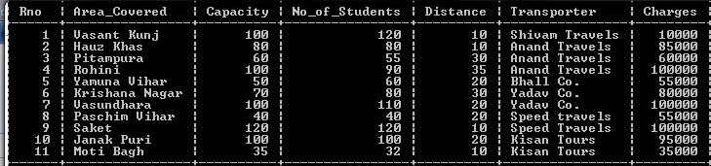

2.
TABLE : GRADUATE
S.NO | NAME | STIPEND | SUBJECT | AVERAGE | DIV.
1 | KARAN | 400 | PHYSICS | 68 | I
2 | DIWAKAR | 450 | COMP. Sc. | 68 | I
3 | DIVYA | 300 | CHEMISTRY | 62 | I
4 | REKHA | 350 | PHYSICS | 63 | I
5 | ARJUN | 500 | MATHS | 70 | I
6 | SABINA | 400 | CEHMISTRY | 55 | II
7 | JOHN | 250 | PHYSICS | 64 | I
8 | ROBERT | 450 | MATHS | 68 | I
9 | RUBINA | 500 | COMP. Sc. | 62 | I
10 | VIKAS | 400 | MATHS | 57 | II

    - List the names of those students who have obtained DIV 1 sorted by NAME.
    - Display a report, listing NAME, STIPEND, SUBJECT and amount of stipend received in a year assuming that the STIPEND is paid every month.
    - To count the number of students who are either PHYSICS or COMPUTER SC graduates.
    - To insert a new row in the GRADUATE table:
11,”KAJOL”, 300, “computer sc”, 75, 1

Create table Graduate(Sno int, name char(10), Stipend int, Subject char(10), Average int, Division char(3));
Insert into Graduate values(1,’KARAN’,’Physics’,68,’I’);
Insert into Graduate values(2,’DIWAKAR’,450,’Comp. Sci.’,68,’I’);
Insert into Graduate values(3,’DIVYA’,300,’Chemistry’,62,’I’);
Insert into Graduate values(4,’REKHA’,350,’Physics’,63,’I’);
Insert into Graduate values(5,’ARJUN’,500,’Maths’,70,’I’);
Insert into Graduate values(6,’SABINA’,400,’Chemistry’,55,’II’);
Insert into Graduate values(7,’JOHN’,250,’Physics’,64,’I’);
Insert into Graduate values(8,’ROBERT’,450,’Maths’,68,’I’);
Insert into Graduate values(9,’RUBINA’,500,’Comp. Sci’,62,’I’);
Insert into Graduate values(10,’VIKAS’,400,’Maths’,57,’II’);
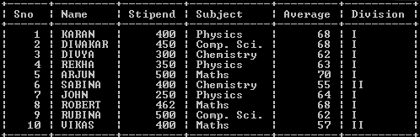
- Select name from graduate where division=’I’ order by name;
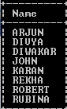

- Select name,stipend,subject,stipend*12 as ‘Yearly Stipend’ from Graduate;
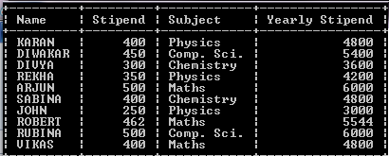
- Select name from graduate where subject=’Comp. Sci.’ or subject=’Physics’;
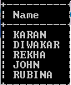
- Insert into Graduate values(11,’KAJOL’,300,’Comp. Sci’,75,’I’);
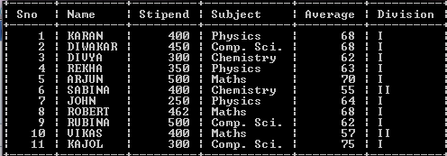

Q3. Write SQL command for (i) to (vii) on the basis of the table SPORTS
Table: SPORTS
Student NO | Class | Name | Game1 | Grade | Game2 | Grade2
10 | 7 | Sammer | Cricket | B | Swimming | A
11 | 8 | Sujit | Tennis | A | Skating | C
12 | 7 | Kamal | Swimming | B | Football | B
13 | 7 | Venna | Tennis | C | Tennis | A
14 | 9 | Archana | Basketball | A | Cricket | A
15 | 10 | Arpit | Cricket | A | Atheletics | C

- Display the names of the students who have grade ‘C’ in either Game1 or Game2 or both.
- Display the number of students getting grade ‘A’ in Cricket.
- Display the names of the students who have same game for both Game1 and Game2.
- Display the games taken up by the students, whose name starts with ‘A’.
- Assign a value 200 for Marks for all those who are getting grade ‘B’ or grade ‘A’ in both
Game1 and Game2.
- Arrange the whole table in the alphabetical order of Name.
- Add a new column named ‘Marks’.

Create table Sports(Student_no int, class int, name char(10),Game1 char(10), Grade1 char(2),Game2 char(10), Grade char(2));
Insert into Sports values(10,7,’Sameer’,’Cricket’,’B’,’Swimming’,’A’);
Insert into Sports values(11,8,’Sujeet’,’Tennis’,’A’,’Skating’,’C’);
Insert into Sports values(12,7,’Kamal’,’Swimmig’,’B’,’Football’,’B’);
Insert into Sports values(13,7,’Veena’,’Tennis’,’C’,’Tennis’,’A’);
Insert into Sports values(14,9,’Archana’,’Basketball’,’A’,’Cricket’,’A’);
Insert into Sports values(15,10,’Arpit’,’Cricket’,’A’,’Atheletics’,’C’);
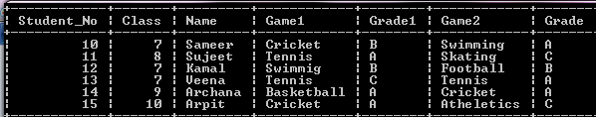
- Select name from sports where Grade1=’C’ or Grade2=’C’;
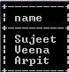
- Select Student_No from sports where (Game1=’Cricket’ or Game2=’Cricket’) and (Grade1=’A’ or Grade2=’A’);
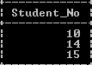
- Select name from sports where Game1=Game2;
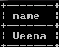
- Select Game1,Game2 from sports where name like “A%”;
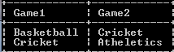

- Select * from sports order by name;
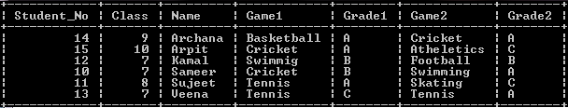
- Alter table sports add marks int;
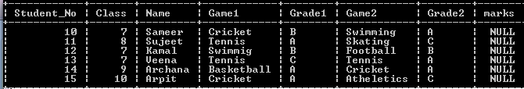
- Update sports set marks=200 where grade1=’A’ or grade2=’A’ or Grade1=’B’ or grade2=’B’;
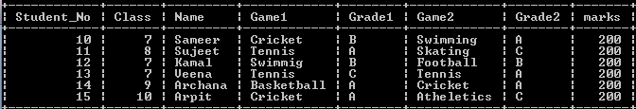

4.
Employees
Empid | Firstname | Lastname | Address | City
010 | Ravi | Kumar | Raj nagar | GZB
105 | Harry | Waltor | Gandhi nagar | GZB
152 | Sam | Tones | 33 Elm St. | Paris
215 | Sarah | Ackerman | 440 U.S. 110 | Upton
244 | Manila | Sengupta | 24 Friends street | New Delhi
300 | Robert | Samuel | 9 Fifth Cross | Washington
335 | Ritu | Tondon | Shastri Nagar | GZB
400 | Rachel | Lee | 121 Harrison St. | New York
441 | Peter | Thompson | 11 Red Road | Paris
EmpSalary

Empid | Salary | Benefits | Designation
ar010 | 75000 | 15000 | Manager
105 | 65000 | 15000 | Manager
152 | 80000 | 25000 | Director
215 | 75000 | 12500 | Manager
244 | 50000 | 12000 | Clerk
300 | 45000 | 10000 | Clerk
335 | 40000 | 10000 | Clerk
400 | 32000 | 7500 | Salesman
441 | 28000 | 7500 | salesman

Write the SQL commands for the following :
- To show firstname,lastname,address and city of all employees living in paris
- To display the content of Employees table in descending order of Firstname.
- To display the firstname,lastname and total salary of all managers from the tables Employee and empsalary , where total salary is calculated as salary+benefits.
- To display the maximum salary among managers and clerks from the table Empsalary.

Create table Employees(Emp_Id int,First_name char(10),Last_Name char(10), Address char(20),City char(20));
Insert into Employees values(010,’Ravi’,’Kumar’,’Raj Nagar’,’GZB’);
Insert into Employees values(105,’Harry’,’Waltor’,’Gandhi Nagar’,’GZB’);
Insert into Employees values(152,’Sam’,’Tones’,’33 Eln St.’,’Paris’);
Insert into Employees values(215,’Sarah’,’Ackeman’,’440 US 110’,’Upton’);
Insert into Employees values(244,’Manila’,’Sengupta’,’24 Friends Street’,’New Delhi’);
Insert into Employees values(300,’Robert’,’Samuel’,’9 Fifth Cross’,’Washington’);
Insert into Employees values(335,’Ritu’,’Tandon’,’Shadtri Nagar’,’GZB’);
Insert into Employees values(400,’Rachel’,’Lee’,’121 Harrison St.’,’New York’);
Insert into Employees values(441,’Peter’,’Thomson’,’11 Red Road’,’Paris’);
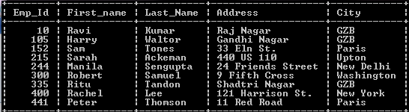

Create table EmpSalary(Emp_Id int,Salary int, Benefits int, Designation char(20));
Insert into EmpSalary values(010,75000,15000,’Manager’);
Insert into EmpSalary values(105,65000,15000,’Manager’);
Insert into EmpSalary values(152,80000,25000,’Director’);
Insert into EmpSalary values(215,80000,12500,’Manager’);
Insert into EmpSalary values(244,50000,12000,’Clerk’);
Insert into EmpSalary values(300,45000,10000,’Clerk’);
Insert into EmpSalary values(335,40000,10000,’Clerk’);
Insert into EmpSalary values(400,32000,7500,’Salesman’);
Insert into EmpSalary values(441,28000,7500,’Salesman’);
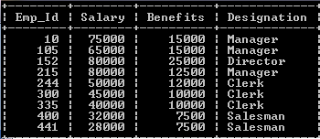
- Select First_name, Last_name, Address,City From Employees where City=”Paris”;
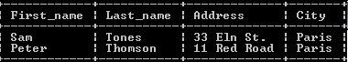
- Select * from Employees order by Last_Name desc;
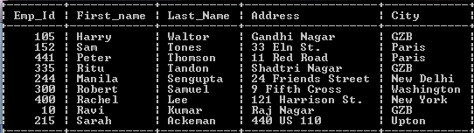
- Select First_Name, Last_Name,Salary+Benefits From Employees,EmpSalary
Where Designation=”Manager” and Employees.Emp_Id=EmpSalary.Emp_Id;
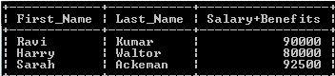
- Select Max(Salary) From EmpSalary Where Designation=”Manager” or Designation=”Clerk”;
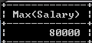

5) Study the following tables STAFF and SALARY and write SQL commands for the question (i) to (iv) and give output for SQL queries (v) to (vi)
relation : STAFF

ID | NAME | DOJ | DEPT | SEX | QUALF
101 | Siddharth | 12/01/02 | Sales | M | MBA
104 | Raghav | 8/05/88 | Finance | M | CA
107 | Naman | 14/05/88 | Research | M | MTECH
114 | Nupur | 1/02/03 | Sales | F | MBA
109 | Janvi | 18/7/04 | Finance | F | ICWA
105 | Rama | 14/4/07 | Research | M | BTECH
117 | Jace | 27/6/87 | Sales | F | MTECH
111 | Binoy | 12/1/90 | Finance | M | CA
130 | Samuel | 7/3/99 | Sales | M | MBA
187 | Ragini | 12/12/02 | Research | F | BTECH

relation : SALARY
ID | BASIC | ALLOWANCE | COMM_PERC
101 | 15240 | 5400 | 3
104 | 23000 | 1452 | 4
107 | 14870 | 2451 | 3
114 | 21000 | 3451 | 14
109 | 24500 | 1452 | 10
105 | 17000 | 1250 | 2
117 | 12450 | 1400 | 3
111 | 13541 | 3652 | 9
130 | 25000 | 4785 | 15
187 | 14823 | 5862 | 2

- Display the name of all CA’s who are working for more than 5 years
- Display the number of staff joined year-wise
- Hike the Allowance of all female staff working in finance sector and joined the company before 2000
- Display the average salary given to the employee in each department
- SELECT DEPT, COUNT(*)
FROM STAFF
WHERE SEX=’m’
GROUP BY DEPT
HAVING COUNT(*) >2

Create table Staff(ID int,Name char(10),DOJ char(8), Dept char(20),Sex char, Qualification char(20));
Insert into Staff values(101,’Siddharth’,’12/01/02’,’Sales’,’M’,’MBA’);
Insert into Staff values(104,’Raghav’,’08/05/88’,’Finance’,’M’,’CA’);
Insert into Staff values(107,’Naman’,’14/05/88’,’Research’,’M’,’MTECH’);
Insert into Staff values(114,’Nupur’,’01/02/03’,’Sales’,’F’,’MBA’);
Insert into Staff values(109,’Janvi’,’18/07/04’,’Finance’,’F’,’ICWA’);
Insert into Staff values(105,’Rama’,’14/04/07’,’Research’,’M’,’BTECH’);
Insert into Staff values(117,’Jace’,’27/06/87’,’Sales’,’F’,’MTECH’);
Insert into Staff values(111,’Binoy’,’12/01/90’,’Finance’,’M’,’CA’);
Insert into Staff values(130,’Samuel’,’07/03/99’,’Sales’,’M’,’MBA’);
Insert into Staff values(187,’Ragini’,’12/12/02’,’Research’,’F’,’BTECH’);
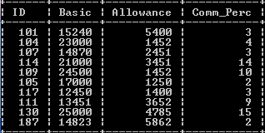

Create table Salary(ID int,Basic int, Allowance int, Comm_Perc int);
Insert into Salary values(101,15240,5400,3);
Insert into Salary values(104,23000,1452,4);
Insert into Salary values(107,14870,2451,3);
Insert into Salary values(114,21000,3451,14);
Insert into Salary values(109,24500,1452,10);
Insert into Salary values(105,17000,1250,2);
Insert into Salary values(117,12450,1400,3);
Insert into Salary values(111,13451,3652,9);
Insert into Salary values(130,25000,4785,15);
Insert into Salary values(187,14823,5862,2);
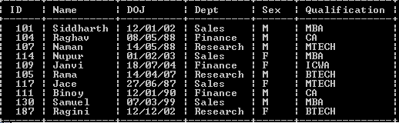
- Select * from staff where Qualification=”CA” and DOJ>01/01/2012;
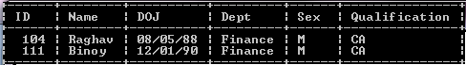
- Select count(*),Dept,DOJ from staff group by DOJ;
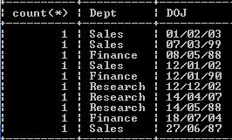
- Select * from staff where Dept=’Finance’ and DOJ<01/01/2000;
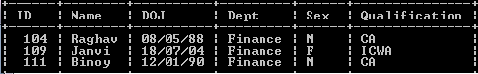
- Select avg(Basic),Dept, from salary,staff where Salary.ID=Staff.ID group by staff.Dept;
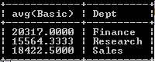

STACKS AND QUEUES
1) Consider the following program for linked QUEUE :
struct NODE
{ int x;
float y;
NODE *next; };

class QUEUE
{ NODE *R,*F;
public :
QUEUE( )
{ R=NULL;
F=NULL;
}
void INSERT( );
void DELETE( );
void Show( );
~QUEUE( ); };
Define INSERT( ) & DELETE( ) functions outside the class.

CODE
#include<conio.h>
#include<stdio.h>
#include<string.h>
#include<process.h>
#include<iostream.h>
struct NODE
{ int x;
float y;
NODE *next; };

class QUEUE
{ NODE *R,*F;
public :
QUEUE( )
{ R=NULL;
F=NULL;
}
void INSERT( );
void DELETE( );
void Show();

};

void QUEUE::INSERT()
{NODE *ptr=new NODE;
cout<<"\nEnter the Value X:: ";
cin>>ptr->x;
cout<<"\nEnter the Value Y:: ";
cin>>ptr->y;
ptr->next=NULL;
if(R==NULL)
R=ptr;
else
{ptr->next=R;
R=ptr;
}
cout<<"\nYour item is inserted. ";
}
void QUEUE::DELETE()
{NODE *temp;
if(F==NULL)
cout<<"\nQueue UnderFlow. Aborting!!! ";
else
{cout<<"\nDeleted Values are:: ";
cout<<F->x<<"\t"<<F->y;
temp=F;
F=F->next;
delete temp;
}
cout<<"\nYour item is deleted. ";
}
void main()
{clrscr();
int n;
QUEUE a;
cout<<"\To insert items press 1, To delete items press 2 :: ";
cin>>n;
if(n==1)
a.INSERT();
else if (n==2)
a.DELETE();
else
cout<<"\nWrong Choice. Aborting!!! ";
getch();
}
OUTPUT
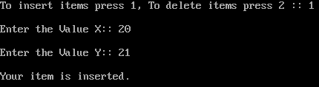

WAP using function to perform PUSH operation in a dynamically allocated stack containing name and registration number of students. Also declare the relevant structure/class and pointers.
CODE
#include<conio.h>
#include<stdio.h>
#include<string.h>
#include<process.h>
#include<iostream.h>
struct student
{ int rollno;
char name[20];
student*link; }*top;
void push()
{student *ptr=new student;
cout<<"\nEnter the rollno:: ";
cin>>ptr->rollno;
cout<<"\nEnter the Name:: ";
gets(ptr->name);
ptr->link=NULL;
if(top==NULL)
top=ptr;
else
{ptr->link=top;
top=ptr;
}
cout<<"\nYour item is inserted. ";
}
void main()
{clrscr();
int n;
cout<<"\To insert items press 1 :: ";
cin>>n;
if(n==1)
push();
else
cout<<"\nWrong Choice. Aborting!!! ";
getch();
}
OUTPUT
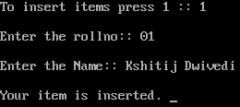

WAP using function Quedel( ) in C++ to display and delete an element , from a dynamically allocated Queue containing nodes of the following structure :
struct student
{
int rollno;
char name[20];
student *link;
};

CODE
#include<conio.h>
#include<stdio.h>
#include<string.h>
#include<process.h>
#include<iostream.h>
struct student
{ int rollno;
char name[20];
student*link; };

class QUEUE
{ student *R,*F;
public :
QUEUE( )
{ R=NULL;
F=NULL;
}
void quedel( )
};
void QUEUE::quedel()
{student *temp;
if(F==NULL)
cout<<"\nQueue UnderFlow. Aborting!!! ";
else
{cout<<"\nDeleted Values are:: ";
cout<<F->rollno;
puts(F->name);
temp=F;
F=F->link;
delete temp;
}}
void main()
{clrscr();
int n;
QUEUE a;
cout<<"\To insert items press 2 :: ";
cin>>n;
if(n==2)
a.quedel();
else
cout<<"\nWrong Choice. Aborting!!! ";
getch();
}
OUTPUT
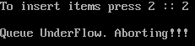

Consider the following portion of a program , which implements names queue for Books .
Write the definition of function Insert(), to insert a new node in the queue with required
information .
struct Book
{
char names[4][20];
};
class QueueofBooks
{
Book Q[10];
public :
int front ,rear;
QueueofBooks()
{
front=rear=-1;
}
void Insert();
void Delete();
};

CODE
#include<conio.h>
#include<stdio.h>
#include<string.h>
#include<process.h>
#include<iostream.h>
struct Book
{
char names[20];
Book *next;
};
class QueueofBooks
{
Book Q[10];
public :
Book *front ,*rear;
QueueofBooks()
{
front=rear=NULL;
}
void Insert();
void Delete();
};

void QueueofBooks::Insert()
{Book *ptr=new Book;
cout<<"\nEnter the name:: ";
gets(ptr->names);
ptr->next=NULL;
if(rear==NULL)
rear=ptr;
else
{ptr->next=rear;
rear=ptr;
}
cout<<"\nYour item is inserted. ";
}

void main()
{clrscr();
int n;
QueueofBooks a;
cout<<"\To insert items press 1:: ";
cin>>n;
if(n==1)
a.Insert();
else
cout<<"\nWrong Choice. Aborting!!! ";
getch();
}
OUTPUT
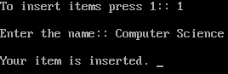

WAP using a function in C++ to perform Insert operation in dynamically allocated Queue containing names of students.

CODE
#include<conio.h>
#include<stdio.h>
#include<string.h>
#include<process.h>
#include<iostream.h>
struct student
{ int rollno;
char name[20];
student*link; };
class QUEUE
{ student *R,*F;
public :
QUEUE( )
{ R=NULL;
F=NULL;
}
void queins( );
};
void QUEUE::queins()
{student *ptr=new student;
cout<<"\nEnter the rollno:: ";
cin>>ptr->rollno;
cout<<"\nEnter the name:: ";
gets(ptr->name);
ptr->link=NULL;
if(R==NULL)
R=ptr;
else
{ptr->link=R;
R=ptr;
}
cout<<"\nYour item is inserted. ";
}

void main()
{clrscr();
int n;
QUEUE a;
cout<<"\To insert items press 1 :: ";
cin>>n;
if(n==1)
a.queins();
else
cout<<"\nWrong Choice. Aborting!!! ";
getch();
}
OUTPUT
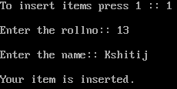

Write a program function in C++ to perform insert operation on a dynamically allocated Queue.
struct Node
{
Int Code;
char Description[10];
Node * link;
}

CODE
#include<conio.h>
#include<stdio.h>
#include<string.h>
#include<process.h>
#include<iostream.h>
struct NODE
{
int code;
char description[10];
NODE *next;
}
class QUEUE
{ NODE *R,*F;
public:
QUEUE()
{ R=NULL;
F=NULL;
}
void INSERT();
};

void QUEUE::INSERT()
{NODE *ptr=new NODE;
cout<<"\nEnter the code:: ";
cin>>ptr->code;
cout<<"\nEnter the Description:: ";
gets(ptr->description);
ptr->next=NULL;
if(R==NULL)
R=ptr;
else
{ptr->next=R;
R=ptr;
}
cout<<"\nYour item is inserted. ";
}

void main()
{clrscr();
int n;
QUEUE a;
cout<<"\To insert items press 1:: ";
cin>>n;
if(n==1)
a.INSERT();
else
cout<<"\nWrong Choice. Aborting!!! ";
getch();
}
OUTPUT
Write a program function in C++ to perform delete operation on a dynamically allocated Queue.
struct Node
{
Int Code;
char Description[10];
Node * link;
}

CODE
#include<conio.h>
#include<stdio.h>
#include<string.h>
#include<process.h>
#include<iostream.h>
struct NODE
{
int code;
char Description[10];
NODE *next;
}
class QUEUE
{ NODE *R,*F;
public :
QUEUE( )
{ R=NULL;
F=NULL;
}
void DELETE( );

};

void QUEUE::DELETE()
{NODE *temp;
if(F==NULL)
cout<<"\nQueue UnderFlow. Aborting!!! ";
else
{cout<<"\nDeleted Values are:: ";
cout<<F->code;
puts(F->Description);
temp=F;
F=F->next;
delete temp;
}
}
void main()
{clrscr();
int n;
QUEUE a;
cout<<"\To delete items press 2 :: ";
cin>>n;
if (n==2)
a.DELETE();
else
cout<<"\nWrong Choice. Aborting!!! ";
getch();
}
OUTPUT

